**Input and Output Examples**

There are two methods to provide resumes to the model:

1. Manually copy the resume content and input it directly into the designated code area.
2. Upload a PDF file of the resume directly to the model.

**Method 1: Example of copying resume content and pasting it in the designated code area:**

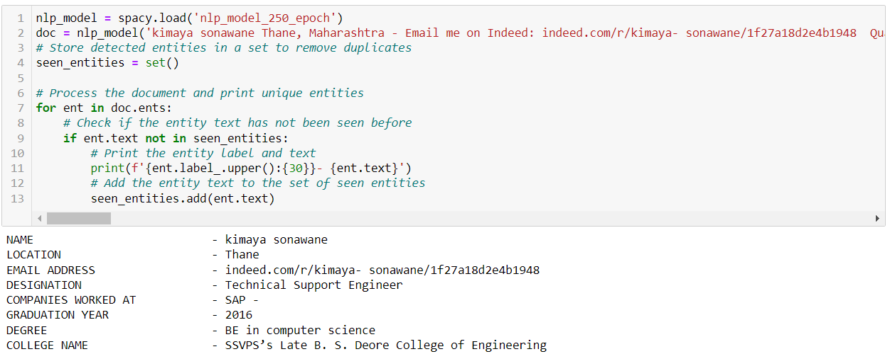

**Method 2: Example of Uploading a PDF Resume to the Model:**

**Input:**

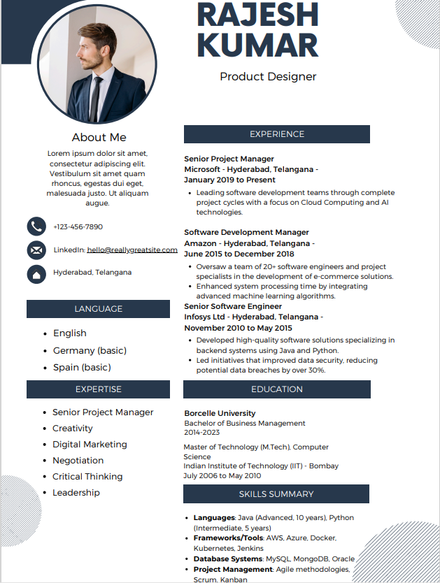

**Output:**

